AWS Honeypot with OpenCanary project
🎯 Project Purpose
This project was built to help me sharpen my cloud detection and response skills using AWS-native tools. I wanted to simulate what a real organisation might build if they needed lightweight early-warning sensors - not just logs sitting in S3, but actual alerting and automation.
It’s part of a series of AWS security projects I’ve been building to grow my portfolio and apply the knowledge I gained from passing the AWS Certified Security – Specialty exam. This one focuses on infrastructure deception and cloud-native automation. This is the kind of thing a SOC team might deploy to detect early-stage attackers scanning cloud assets.
🏛️ Architecture Diagram
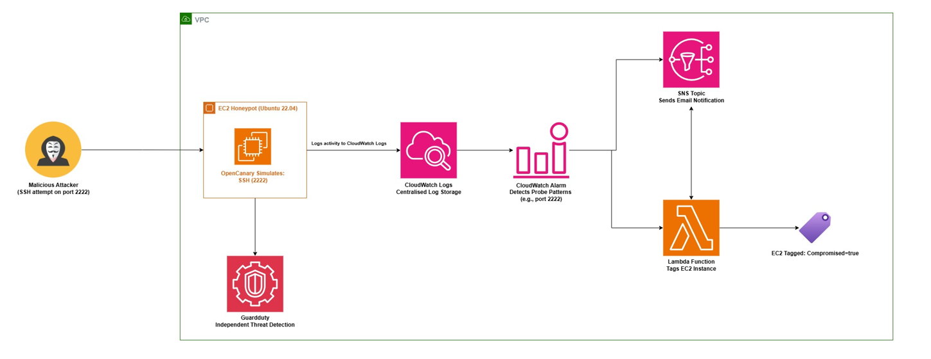
🔍 Real-World Scenario
This project simulates threat detection in a cloud-native AWS environment by deploying a honeypot that emulates common services like SSH, FTP, and HTTP. If an attacker or automated scanner were to probe one of these services, the system would log the event, raise an alert, and automatically trigger a response pipeline.
The honeypot is designed for operational detection rather than research. It focuses on automating security responses, tagging compromised assets, and integrating seamlessly with services like CloudWatch, Lambda, and GuardDuty.
🔢 Step-by-Step Breakdown
1. Network Setup
I launched a custom VPC, subnet, route table, and internet gateway. Then I created a Security Group with rules allowing SSH (22) only from my IP, and FTP (21), HTTP (80), and fake SSH (2222) from anywhere.
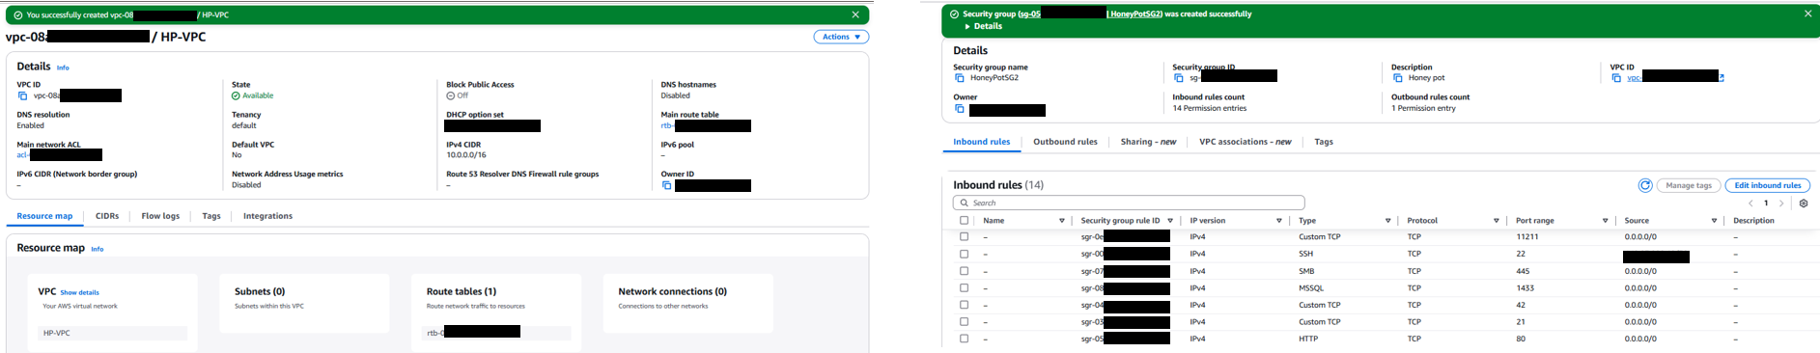
2. EC2 + OpenCanary Setup
I launched a t2.micro EC2 instance running Ubuntu 22.04. I updated the system, installed Python and virtualenv, and created an isolated environment to install OpenCanary.
When trying to run opencanary --copyconfig, I got a command not found error. I resolved this by using opencanaryd --copyconfig, which created a system-wide config file at /etc/opencanaryd/opencanary.conf. I edited the config to enable SSH, HTTP, FTP, and Telnet traps. Since port 22 was already used by real SSH, I set the fake SSH trap to port 2222.
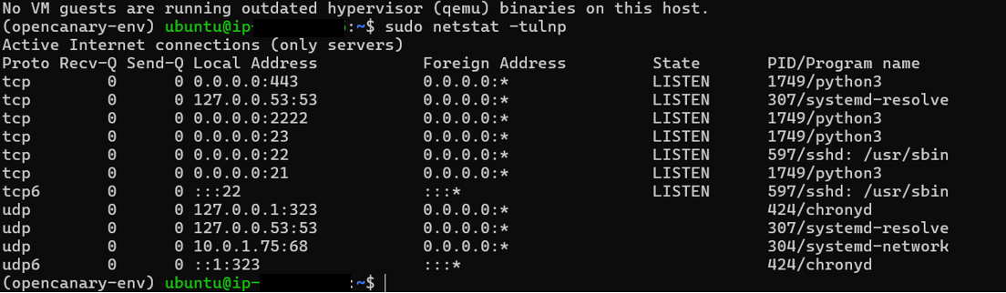
3. CloudWatch Agent Setup
Amazon Linux didn’t include the CloudWatch Agent in its default repos, so I manually downloaded and installed the .deb package. I created a config file that sent /var/tmp/opencanary.log to a CloudWatch Log Group called OpenCanaryHoneypotLogs, and verified that logs were appearing.
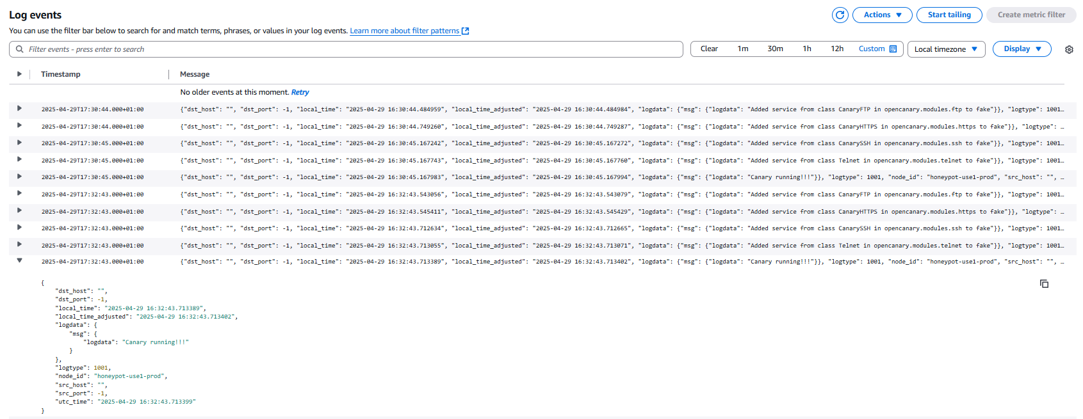
4. Testing the Honeypot
I used nc 127.0.0.1 2222 to test the SSH trap and confirmed that logs were generated. Only port 2222 consistently triggered logs, which I documented as a limitation.
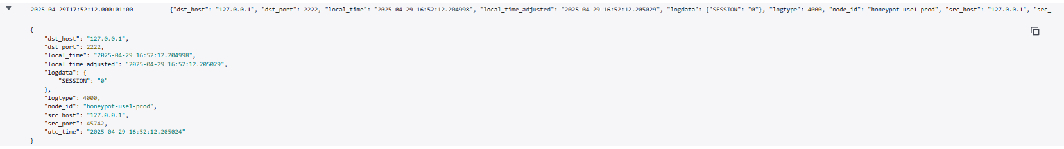
5. Detection & Alerting Pipeline
I created a metric filter to count log entries and an alarm that triggers if at least one log appears within a 5-minute window. I then set up an SNS topic for email notifications and a Lambda function to tag the EC2 instance as Compromised=true.
The Lambda didn’t trigger at first because I forgot to set up a CloudWatch Logs trigger. Once I manually added the trigger, everything worked as expected.
1. # Visualising Detection Logic
2. if "connection attempt" in log and "port 2222" in log:
3. trigger_alarm()
4. tag_instance("Compromised=true")
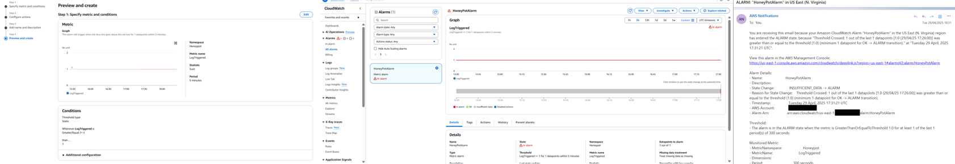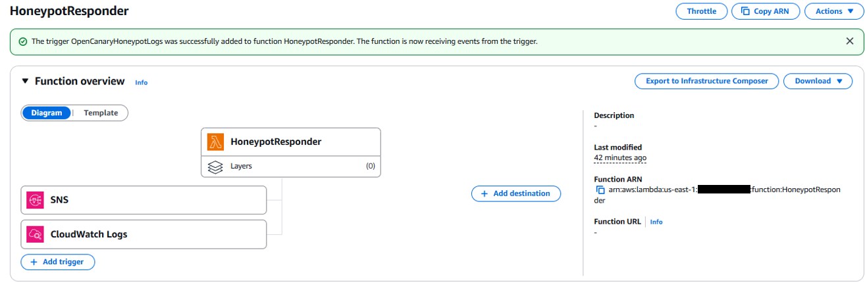
6. GuardDuty Integration
I enabled GuardDuty in us-east-1, and after scanning the honeypot, GuardDuty raised a detection on the fake SSH port. While I didn’t analyse the payloads, I confirmed GuardDuty’s detection capability against the honeypot probe. 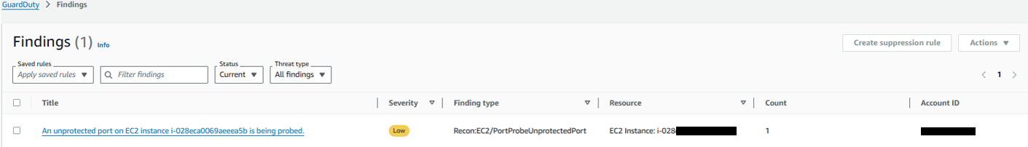
7. Final Actions + Cleanup
After confirming everything worked, I tagged the EC2 instance with Project=Honeypot, triggered a real alert, and watched the Lambda auto-tag it as Compromised=true. I then shut everything down:
- Terminated the EC2 instance
- Deleted VPC, SGs, Lambda, SNS, and CloudWatch log groups
- Double-checked that no leftover resources remained
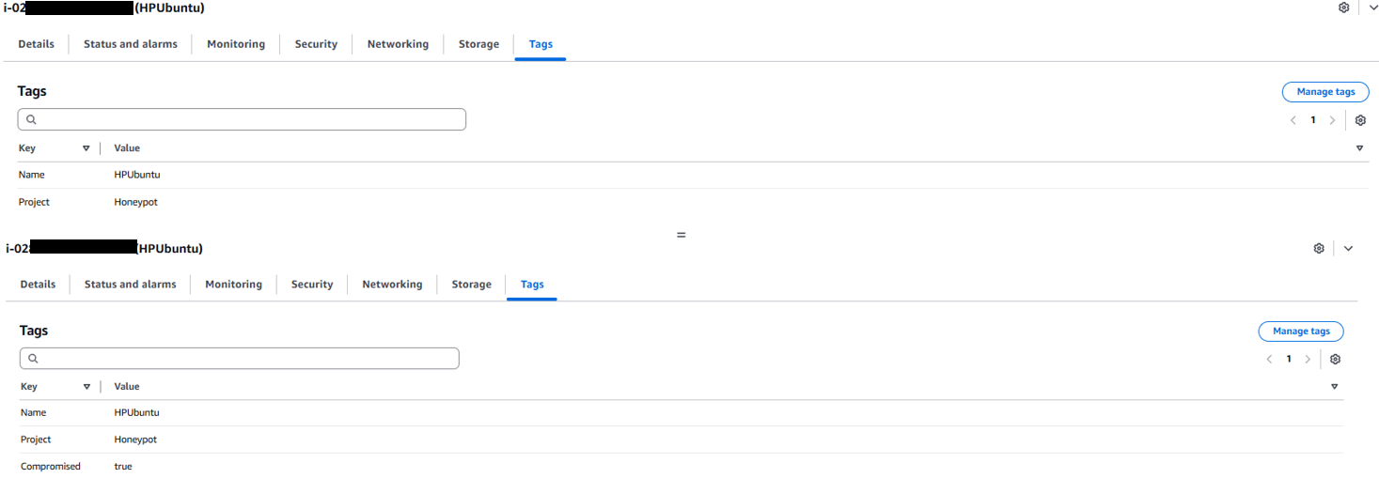
🐞 Issues I Ran Into
Throughout this project, I faced a number of issues that slowed me down but ultimately helped me understand how everything fits together:
- The opencanary --copyconfig command wasn’t found. I realised the CLI version I installed didn’t expose that command, so I switched to opencanaryd --copyconfig.
- Even after using the correct command, the generated file was empty. After some trial and error, I realised OpenCanary had defaulted to using the system-wide config path /etc/opencanaryd/opencanary.conf because a previous version had already created that.
- Port 22 was already in use by the SSH daemon, so OpenCanary couldn’t bind to it. I resolved this by assigning port 2222 for the fake SSH trap.
- The CloudWatch Agent wasn’t available in the Ubuntu package repos, so I downloaded and installed the .deb package directly from Amazon’s official source.
- After launching everything, I noticed that only port 2222 reliably triggered OpenCanary logs. HTTP, Telnet, and FTP traps didn’t consistently generate output, even when hit locally. This became a known limitation in my setup.
- The CloudWatch alarm successfully fired, but the Lambda function didn’t run. I discovered that attaching the Lambda to the alarm wasn’t enough. I also needed to manually configure the function to be triggered by CloudWatch Logs.
These weren’t minor bumps. They were the kind of issues that force deep understanding of AWS service interactions.

What Broke | How I Fixed It
opencanary --copyconfig not found | Used opencanaryd --copyconfig instead
Empty config | Used the system-wide config in /etc/opencanaryd
Port conflict with real SSH | Changed honeypot SSH to port 2222
CloudWatch Agent not available | Installed it manually from AWS’s S3 link
Lambda didn’t trigger | Manually added CloudWatch Logs as trigger

📸 Screenshot Summary
- VPC and Security Group configuration
- OpenCanary config file (/etc/opencanaryd/opencanary.conf)
- Netstat output showing OpenCanary ports listening
- CloudWatch Log Group showing OpenCanary logs
- Log entry generated from port 2222 test
- CloudWatch Alarm with SNS and Lambda attached
- Lambda trigger settings showing CloudWatch Logs as the source
- GuardDuty finding showing port 2222 probe
- EC2 instance with Compromised=true tag
🔪 Final Thoughts
This project gave me real-world experience in building and wiring together a cloud-native detection pipeline. I didn’t focus on analysing attacker payloads - that wasn’t the point. The goal was detection, alerting, and automatic response.
I now have a working system that:
- Simulates fake infrastructure
- Triggers logs when touched
- Sends alerts
- Tags resources in real time
- Is validated by GuardDuty
If I were to improve it further, I’d:
- Use Kibana or OpenSearch to visualise logs
- Add external probes with Nmap for realism
- Make the Lambda dynamically detect instance IDs
- Push logs to S3 for long-term archival and analysis
🔎 Summary for CV/GitHub:
✅ Simulated attacker probe with OpenCanary
✅ Real-time log detection and tagging with Lambda
✅ GuardDuty confirmed external detection

